Sharing of Ministry Announcements

Prelude Mark Hayes
“America, the Beautiful”

Call to Worship
Leader: We seek the guidance of the Spirit to be free in
Christ and resist the yoke of slavery.
People: We seek the guidance of the Spirit to love our
neighbors as ourselves.
Leader: We seek the guidance of the Spirit to live with self-
control, gentleness and joy.
People: We seek the guidance of the Spirit to be the
people Christ calls us to be.

Opening Hymn UMH, Number 698
“God of the Ages”

*Opening Prayer (in unison)
Holy and loving God, we desire for our lives what you desire for us: freedom, peace, joy, gentleness, self-control, and to love our neighbors as ourselves. We pray that your Spirit may work within us today: guiding us, teaching us, challenging us. Help us live by the Spirit. Amen.

Special Music by Hall/Herms “Blessed Redeemer” Doreen Mileto, soloist

Children’s Message

Anointing

A Time of Prayer
- Prayer of Petition
- “The Lord’s Prayer” Our Father, who art in heaven, hallowed be thy name. Thy kingdom come, thy will be done on earth as it is in heaven. Give us this day our daily bread. And forgive us our trespasses, as we forgive those who trespass against us. And lead us not into temptation, but deliver us from evil. For thine is the kingdom, and the power, and the glory, forever. Amen.

A Call to Faithful Giving
Offertory Spiritual, arr. Cindy Berry
“We are Climbing Jacob’s Ladder”

Scripture Lesson Galatians 5:1, 13-15

Hymn UMH, Number 697
“America”

Sermon Rev. Dr. Lori Betsworth
“Freedom in Christ”

Holy Communion Liturgy (see insert)

Holy Communion

Prayer after Communion (see insert)

Closing Hymn UMH, Number 121
“There’s Wideness in God’s Mercy”

Benediction

Postlude arr. Cindy Berry
“America (My Country, ‘Tis of Thee)”

We thank Irenay Weaver for serving as our worship accompanist this weekend.

Our Acolytes Serving You Our Lay Readers Serving You
Donna Wheeland – 5:30am Donna Wheeland – 5:30pm
Cade Lusk – 8:15am Lynne Girardi – 8:15am
Anna Manetta – 10:45am Robert Weaver – 10:45am

Sound Board Operator Screen Graphics Operator
Lew Litz – 8:15am Bob Burns – 5:30pm
Daun Williamson – 10:45am Dave Bower – Sunday

Graphics Originator
Doreen Mileto

Ushers/Greeters
8:15am 10:45am
Jordan Downey Kevin Floyd
Bill Encke Carl Floyd
Ed Souter, Sr. Aaron Keller

Anointing
If there is anyone present today who is scheduled to enter the hospital this week, to stay or for one day surgery, or if you are burdened with an issue and could use some support, we would be pleased, when invited, to have you come up front with the pastor for Anointing and prayer to support you.

Prayer Requests
If you would desire prayer today for a friend or family member and the Church Office is not aware of your desire, please clearly write that request on the attendance sheet or call the Church Office during normal office hours at 570 326-5569.

Invitation
We are inviting everyone to a RECEPTION for Pastor Lori and Brian. It will be on JULY 10th. It will be during the Sunday School hour continuing after the last service at 10:45am. Hoping to see each of you to WELCOME them to Saint John’s-Newberry. There will be refreshments. If you are unable to be here on the 10th, there will also be a Meet and Greet after the 5:30pm service on Saturday July 9th. It will be in the Gathering area with refreshments being served. It is a Blessing to welcome them and to pray together, but most of all getting to know each of us. Hope to see everyone.

Meet and Greets
Please consider hosting a meet and greet with Pastor Lori sometime in the months of July, August or September, in the church lounge or at your home. Contact Lee Ann Ditty at 570-971-9166

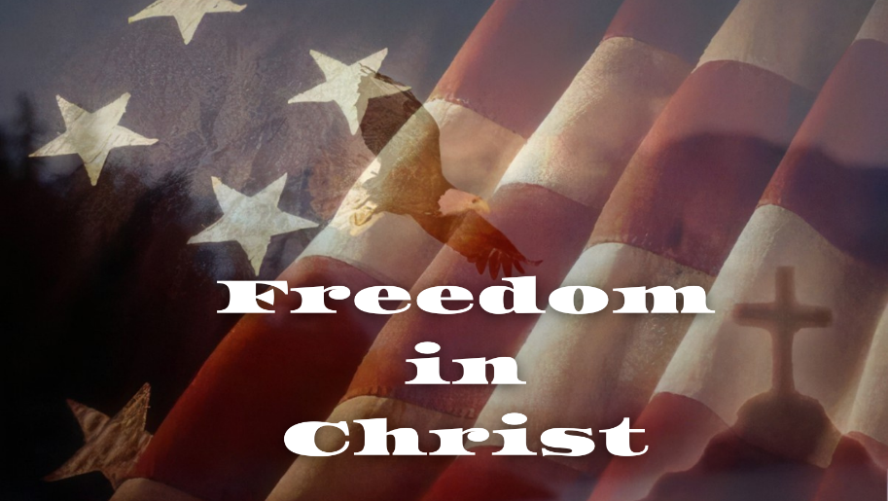

________________________________________________
Fourth Weekend after Pentecost
a celebration of worship
July 2 and 3, 2022
________________________________________________
Saint John’s-Newberry
United Methodist Church
Embracing the community with God’s love.

2101 Newberry Street Office - 570/326-5569
Williamsport, PA 17701-1361 Fax - 570/326-5867
http://stjnumc.com

