Sharing of Ministry Announcements

Prelude by Robert Lau
“Comfort, Comfort Ye My People”

Call to Worship
Leader: A voice cries out in the wilderness: “Prepare the
way of the Lord!”
People: Make God’s paths straight.
Leader: Every valley will be filled, and every mountain will
be leveled.
People: The crooked will be made straight.
Leader: The rough and rocky ways will be smoothed.
People: All will see the salvation of God.
Leader: See the light from on high. The dawn is breaking.
People: The Lord is coming!

Opening Hymn UMH, Number 209
“Blessed Be the God of Israel”

Opening Prayer
Patient and loving God, we so easily launch ourselves in preparation for the secular festival of giving and parties and the swirl of social events; but we forget that the true preparation is the readiness of our hearts to receive you. Help us look again at our lives and turn them around so that they may be in tune with your will. We ask this in Jesus’ Name, AMEN.

The Lighting of the Advent Candle: PEACE

Scripture Reading (Video) Isaiah 40: 1-11

Reader 1: From the foundation of Jesse, from the stump, there
shall come a new shoot!
Reader 2: God’s spirit shall rest upon him.
Reader 1: He shall find delight in all of God’s creation!
Reader 2: Peace shall reign – old enmities shall cease! For on
that day we will celebrate God’s love with one
another.
Reader 1: Today we light two candles. The first is the candle of Hope in the promise of the Coming Messiah. [Reader 2 to light the first candle]
The second candle is the candle of PEACE, enabling us to look at our world, to get rid of all those things that keep us from experiencing peace with God and with one another. [Reader 2 to light the second candle]

Special Music SOTA Dancers

Children’s Message
** Children, please remain in your seats. We will all enjoy the message together.

A Time of Prayer
- Prayer of Petition
- “The Lord’s Prayer” Our Father, who art in heaven, hallowed be thy name. Thy kingdom come, thy will be done on earth as it is in heaven. Give us this day our daily bread. And forgive us our trespasses, as we forgive those who trespass against us. And lead us not into temptation, but deliver us from evil. For thine is the kingdom, and the power, and the glory, forever. Amen.

A Call to Faithful Giving
Offertory arr. by Michael Thomas
“O Come, O Come Emmanuel”

Scripture Reading (Video) Isaiah 9: 2-7

Sermon Rev. Dr. Lenore Hosier
“Because of Bethlehem we have Peace”

Sacrament of Holy Communion

Closing Hymn UMH, Number 210
“Toda la Tierra”

Dismissal with Blessing

Postlude arr. by Jason D. Payne
“Postlude on ‘Hyfrydol’”

Our Acolytes Serving You Our Lay Readers Serving You
Evan Hartzel – 8:15am Ann Burns – 5:30pm
Dante Cruz – 10:45am Kent Weiland – 8:15am
Barry Rake – 10:45am

Sound Board Operator Graphics Originator
Brandon DeArment – Sunday Rob Hosier

Screen Graphics Operators
Bob Burns – 5:30pm
Lew Litz - Sunday

Ushers Serving You
5:30pm 8:15am
Lynn Broughton John Springman
Carl Livermore David Livermore
Tony Mileto David Cappa
Bob Thomas Penny Cappa

December Mission Project: Gatehouse Hospice
Housed in the former Divine Providence Hospital, the Gatehouse is a place for those individuals and families facing terminal illnesses.

Copies of the November 2020 Church Council Report are available on the information table in the lounge for anyone who is interested.

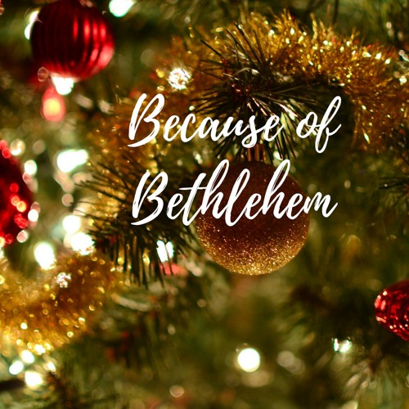

________________________________________________
Second Weekend of Advent
a celebration of worship
December 5 & 6, 2020
________________________________________________
Saint John’s-Newberry
United Methodist Church
Embracing the community with God’s love.

2101 Newberry Street Office - 570/326-5569
Williamsport, PA 17701-1361 Fax - 570/326-5867
http://stjnumc.com

